# Sniffing Attack task-3

**Step 1 )** Start wireshark and clik on wifi so that it will start capturing the data packets that are travelling through your wifi 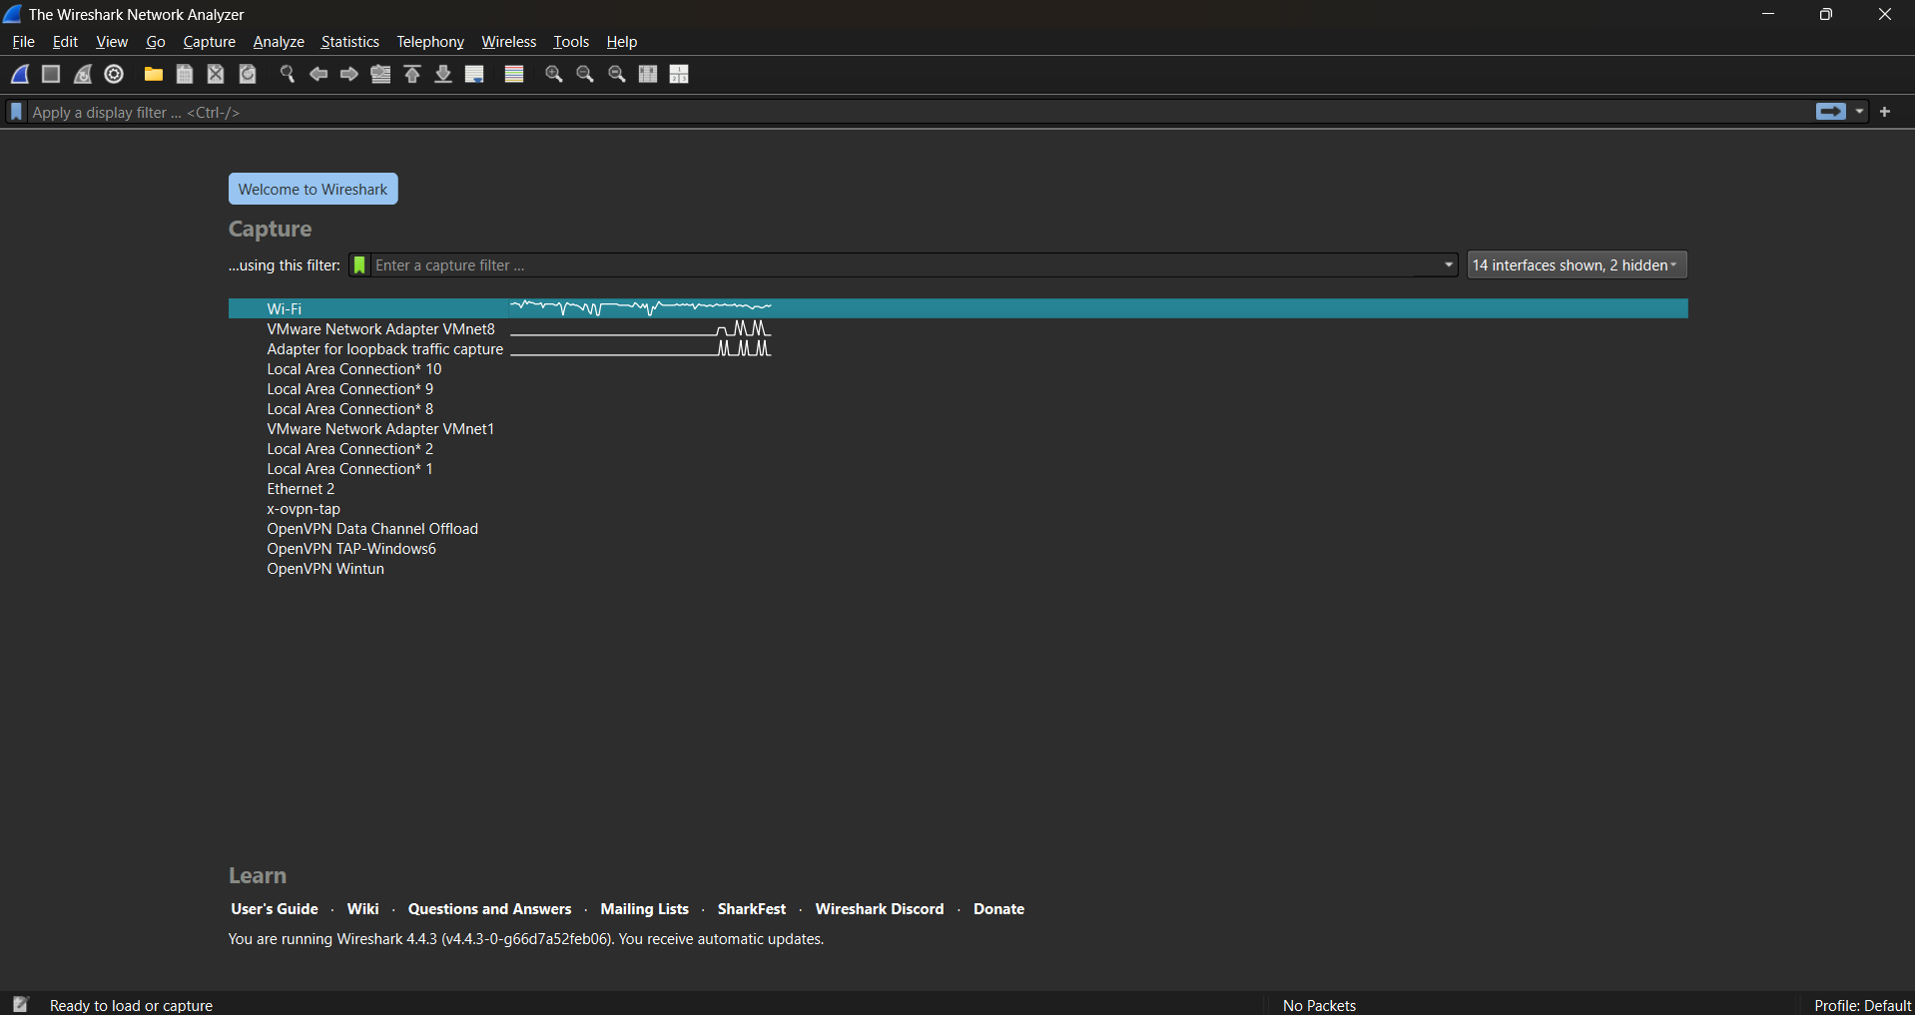

**Step 2)** Open the browser and open the target site <http://testphp.vulnweb.com/> and go to signup page. Enter the details.

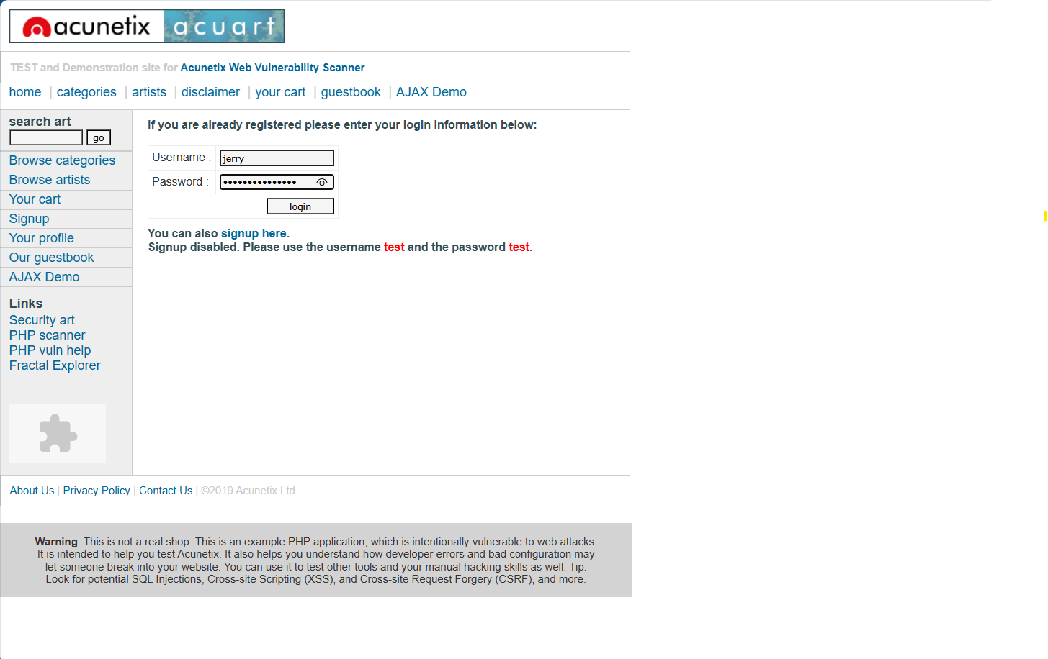

**Step 3)** Click on login and parallely observe the the traffic in wireshark.

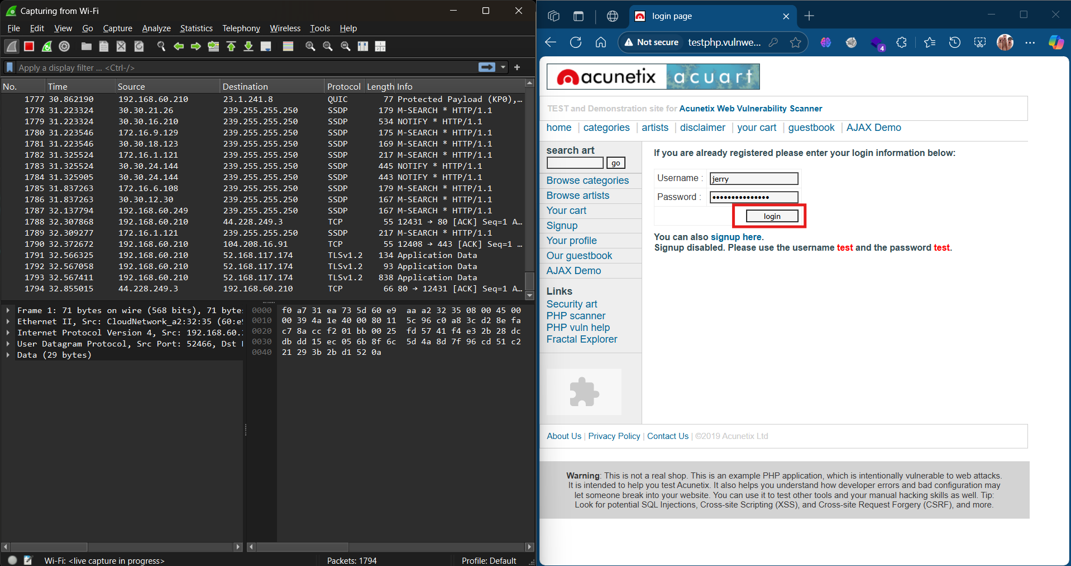

**Step 4)** Click on red square to stop capturing data packets

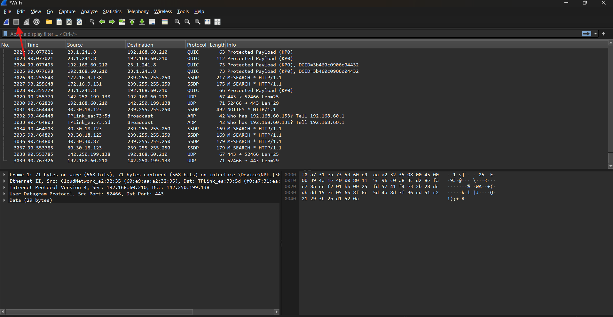

**Step 5)** Apply http filter to view only http traffic captured.

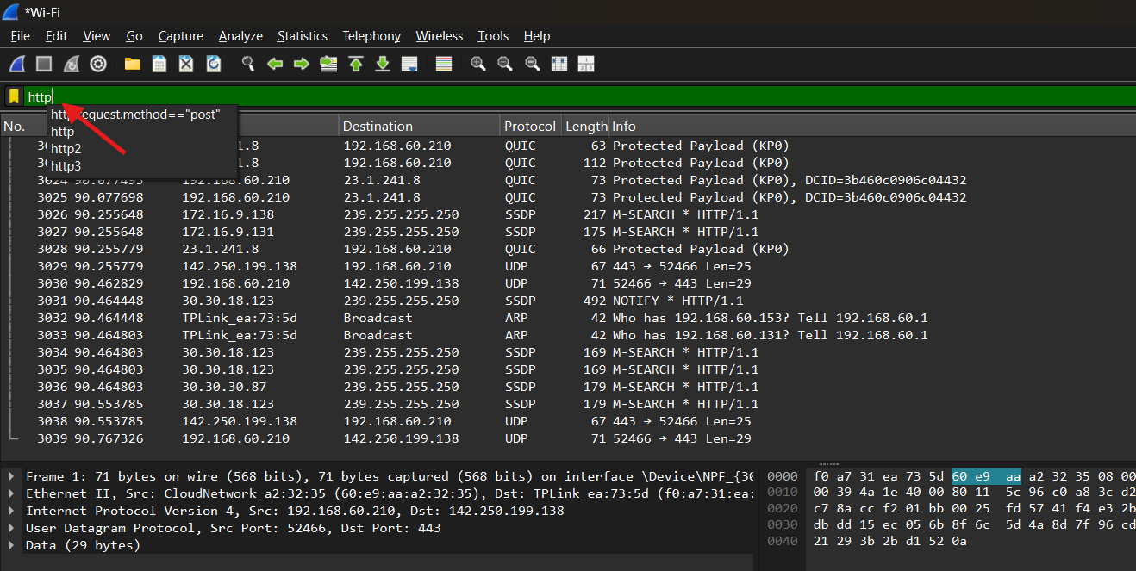

**Step 6)**  Look for the packet labelled as userinfo.php

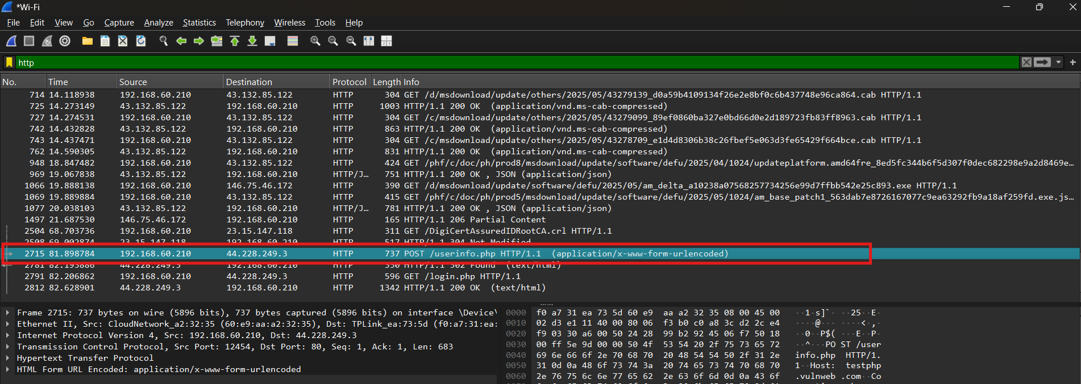

**Step 7)** Inspect the that packet by clicking on it. Check the data encoded part at last.

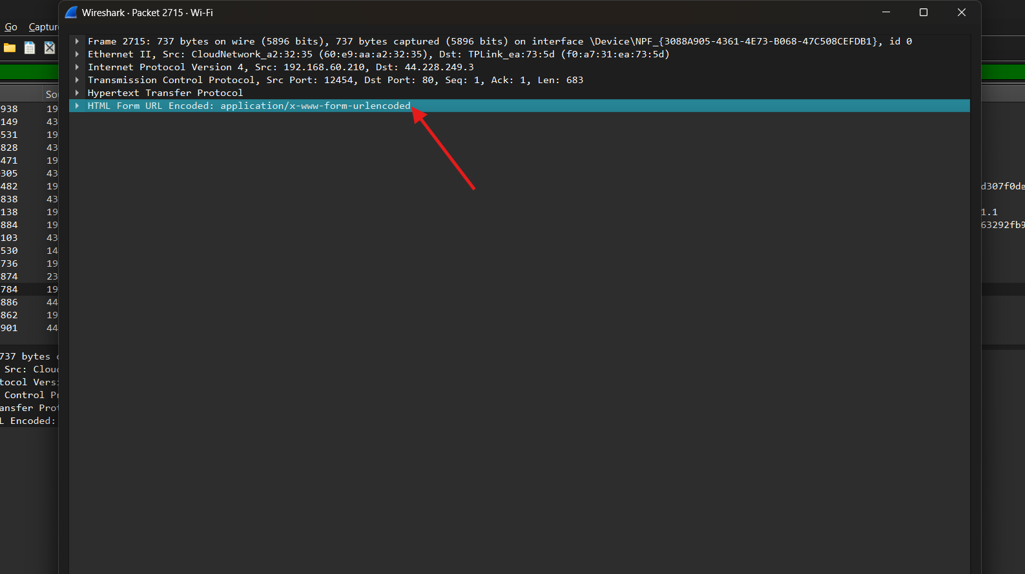

It will show you the username and password that was sending to backend. Like this

